**Project Design Phase-II**

**Data Flow Diagram & User Stories**

|  |  |
| --- | --- |
| Date | 15 October 2022 |
| Team ID | PNT2022TMID33058 |
| Project Name | Project - Project - Detecting Parkinson’s  Disease using Machine Learning. |
| Maximum Marks | 4 Marks |

**Data Flow Diagrams:**

A Data Flow Diagram (DFD) is a traditional visual representation of the information flows within a system. A neat and clear DFD can depict the right amount of the system requirement graphically. It shows how data enters and leaves the system, what changes the information, and where data is stored.

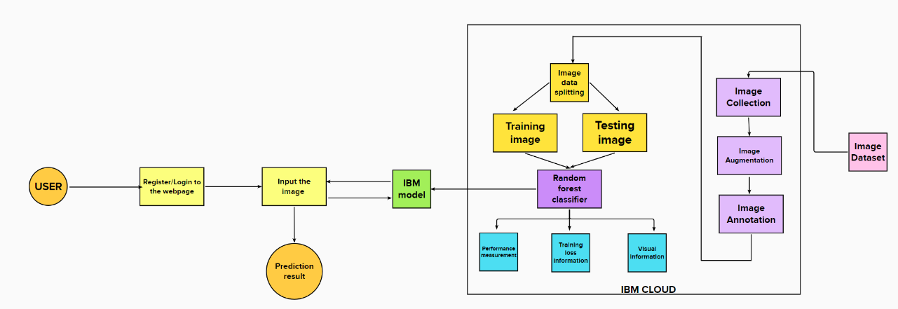

**User Stories**

Use the below template to list all the user stories for the product.

|  |  |  |  |  |  |  |
| --- | --- | --- | --- | --- | --- | --- |
| **User Type** | **Functional Requirement (Epic)** | **User Story Number** | **User Story / Task** | **Acceptance criteria** | **Priority** | **Release** |
| Customer (Web  user) | HomePage | USN-1 | Description about Parkinson's disease. | I can get an idea about the disease. | Low | Sprint-3 |
|  |  | USN-2 | Details about the test vitals required for the testing. |  | Low | Sprint-3 |
|  | Registration | USN-3 | As a user, I can register for the  application by entering my username, email, phone number, and password, and confirming my password. | I can access my  account. | Moderate | Sprint-3 |
|  |  | USN-4 | As a user, I will receive a  confirmation mail once I have registered for the application. | I can receive a  confirmation OTP upon registration for verification. | High | Sprint-3 |
|  | Login | USN-5 | As a user, I can log in to the web  application by entering my email id & password. | I can log in  successfully. | High | Sprint-2 |
|  | Main  Page(Test vitals) | USN-6 | As a user, I submit the required  image for the prediction. | I can access the  page and can submit the input. | Moderate | Sprint-4 |
|  | Results | USN-7 | Results will be displayed along with  their accuracy. | I got my results  successfully and accurately. | High | Sprint-4 |
| Admin | Data  collection | USN-8 | Collect the required data for the  detection of Parkinson's disease |  | High | Sprint-1 |
|  | Data preprocessing | USN-9 | Clean and analyze the data to avoid noise and duplications | As a result I get the desired dataset to get trained. | High | Sprint-1 |
|  | Model  Building | USN-10 | Build the model using a Random  forest classifier to classify the images. | Successfully  trained the model. | High | Sprint-1 |
|  | Deploy the  model | USN-11 | Deployment of ML model using  IBM Watson Studio, object storage. | Deployed  successfully. | High | Sprint-2 |
|  | Integrate the web app with the IBM model | USN-12 | Use flask for the integration purpose. | Created the web app successfully. | Moderate | Sprint-2 |